To Database as a Service (DaaS) create and configure a new VM Image in any Public Cloud Service Provider

**Implementation:**STEP:1: CRAETE A DATA BASE SERVER.

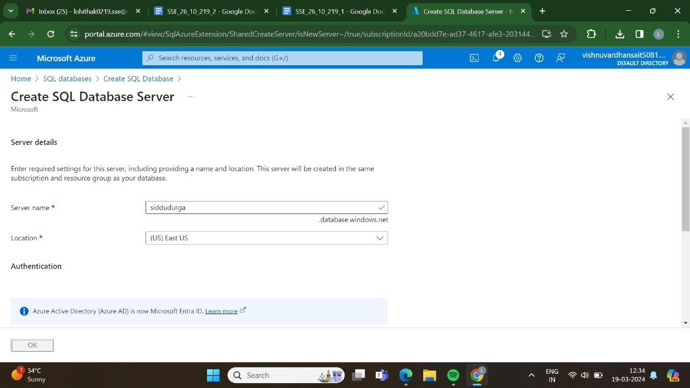STEP:2:AND,THEN GO FOR THE BASICS.

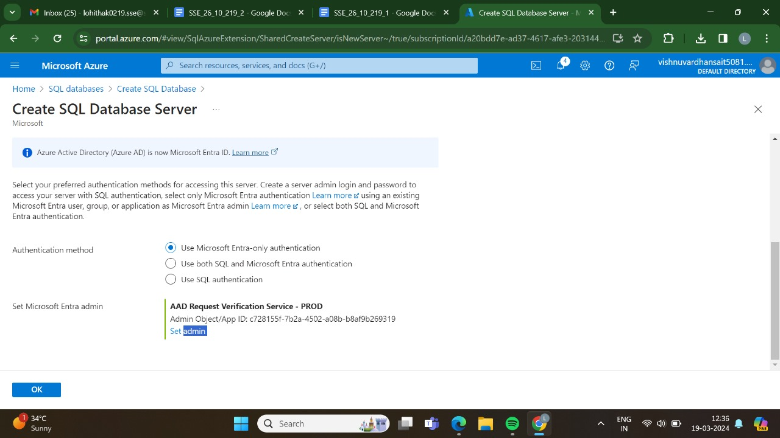

STEP:3:AND ,THEN GO FOR THE NETWORKING.

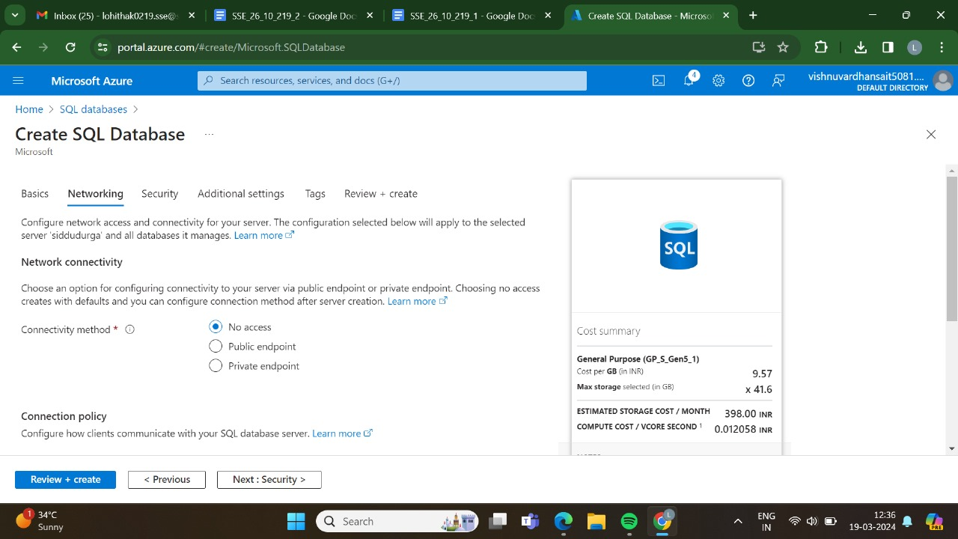

STEP:4:AND,THEN GO FOR THE SECURITY.

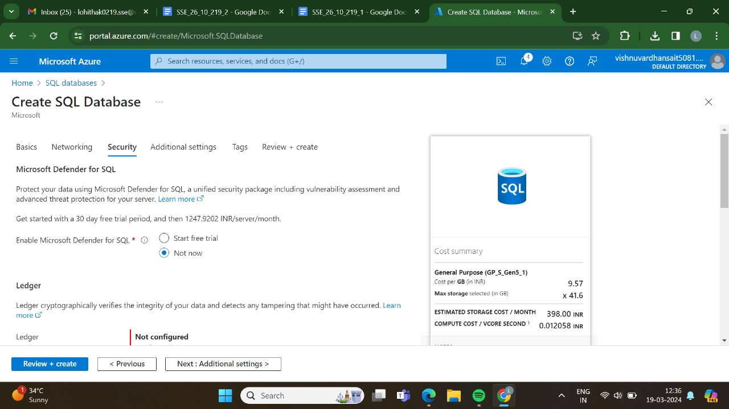

STEP:5:: AND,THEN GO FOR THE ATTIDIONAL SETTINGS.

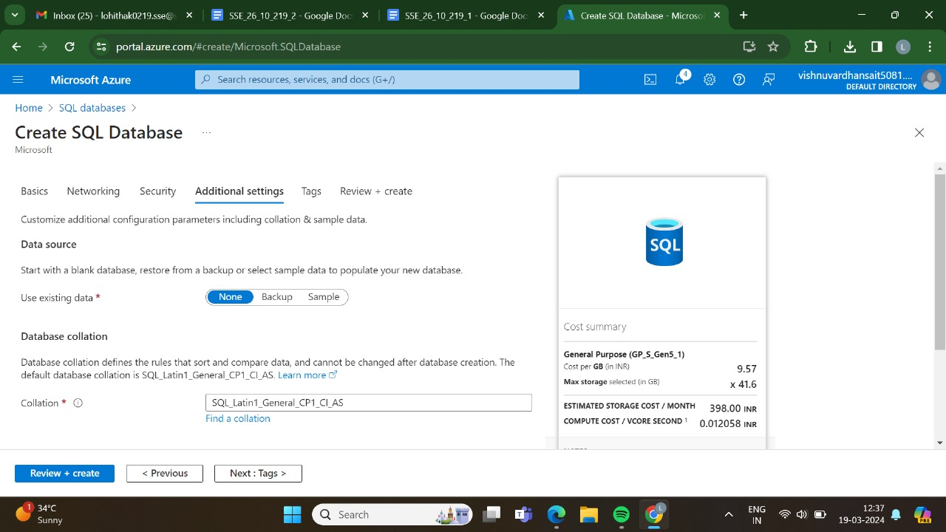

STEP:6:: AND,THEN GO FOR THE TAGS.

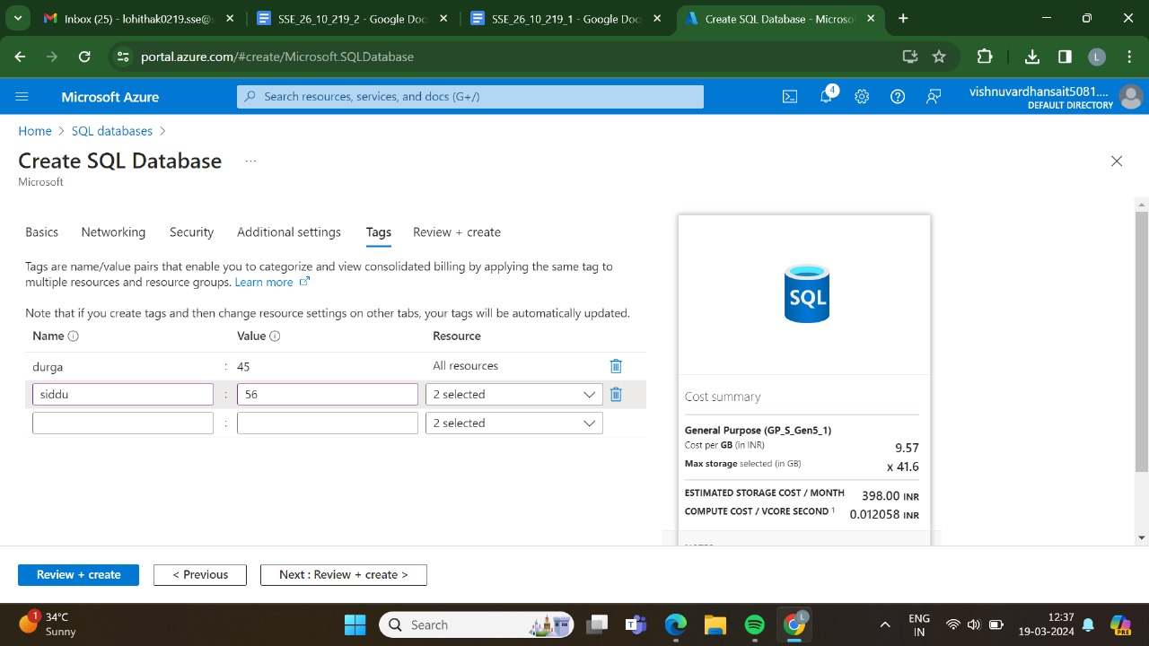

STEP:7:AND,THEN GO FOR THE REVIEW +CRAETE AND CLICK CREATE.

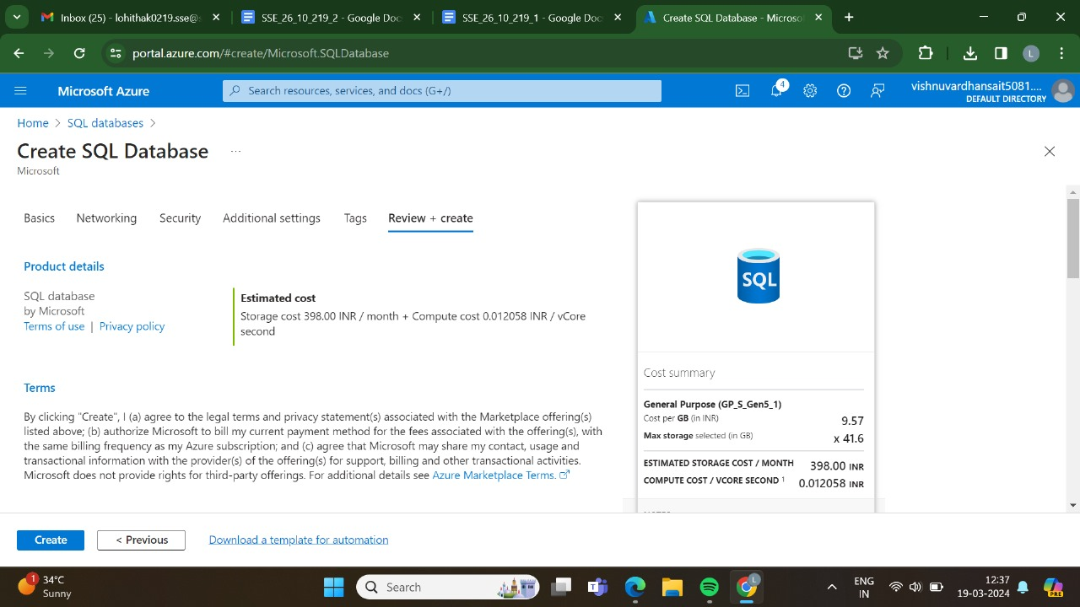

STEP:8: AND THEN GO FOR THE CREATE.



STEP:9:DEPLOYMENT IS IN PROGRESS.

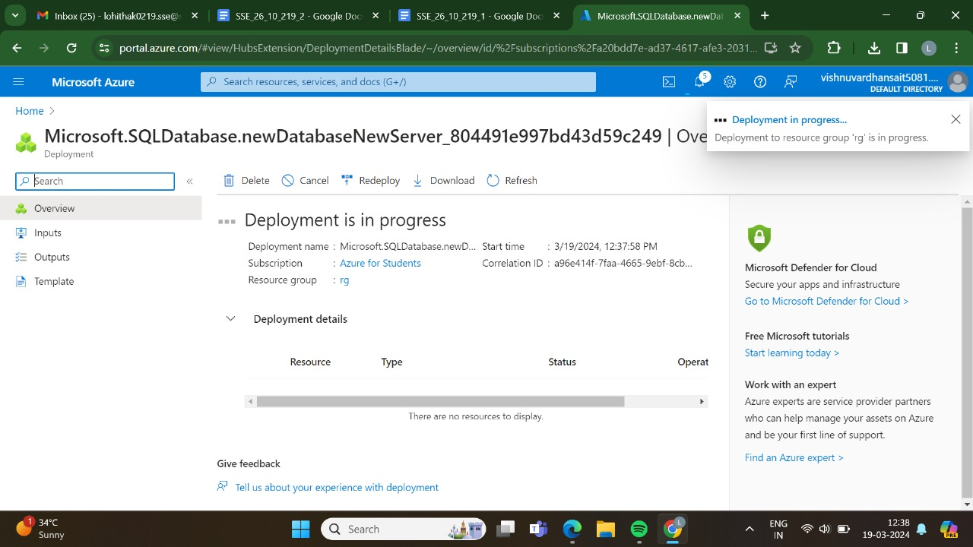

STEP:10:THE DEPLOYMENT HAS BEEN DONE SUCCESSFULLY.

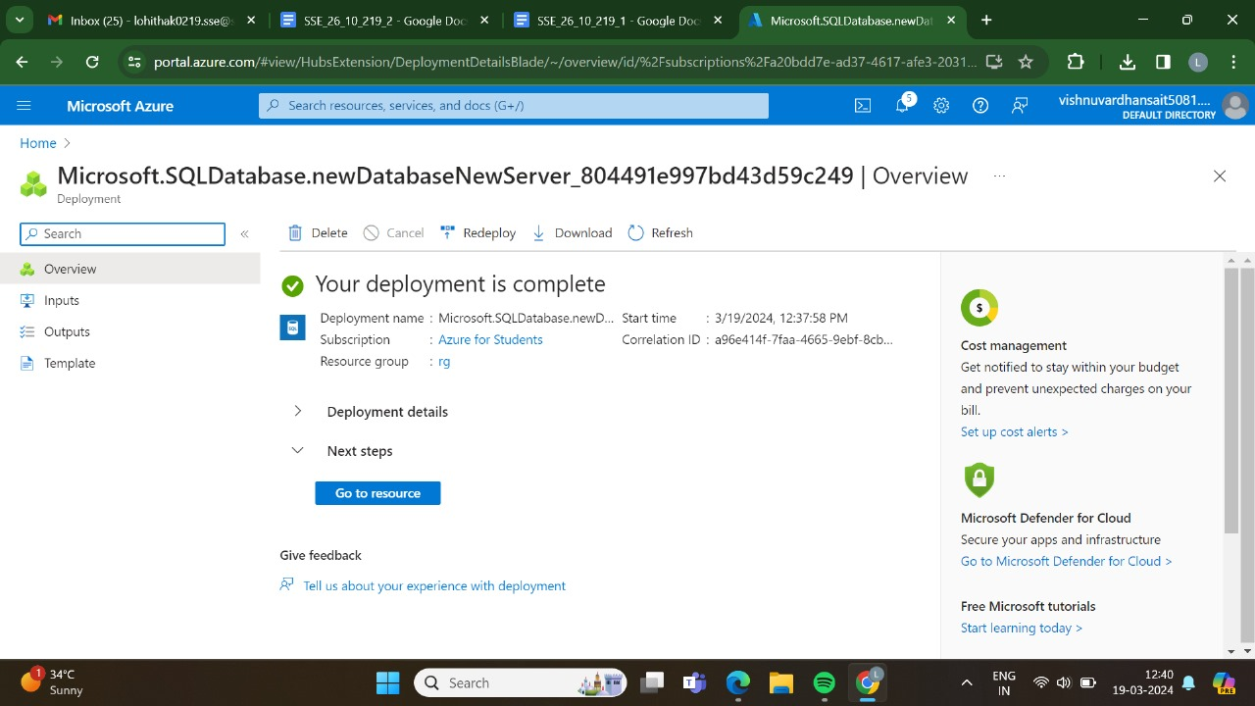

STEP:11:HERE,IS THE OUTPUT FOR THE SQL DATABASE SERVER.

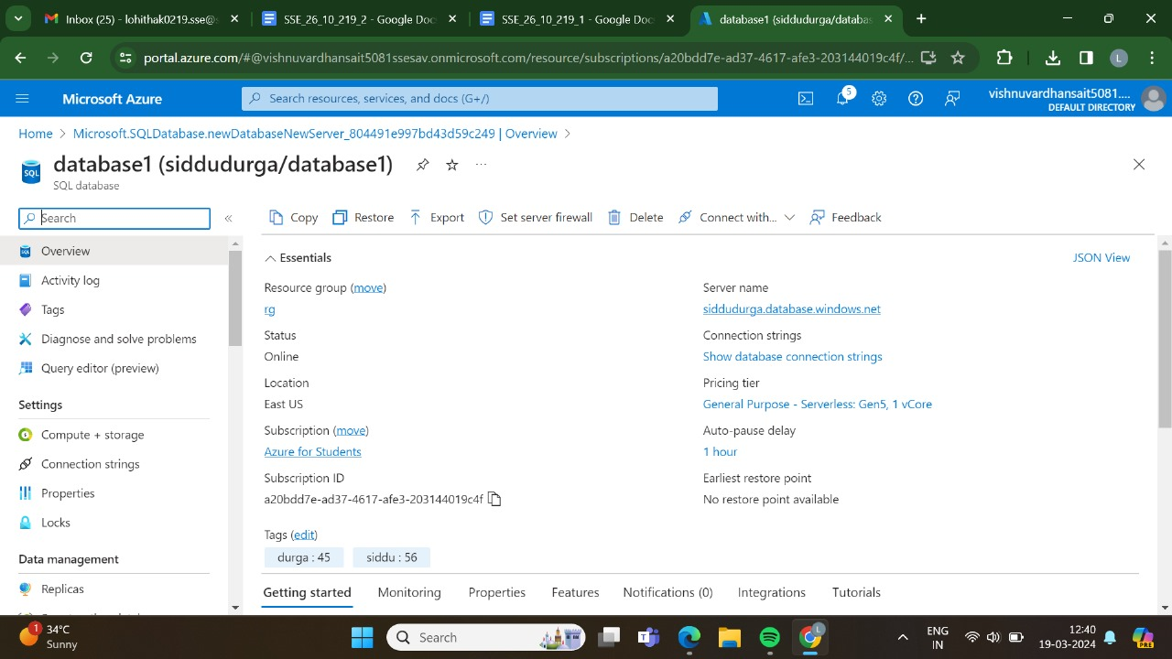

RESULT:THUS,THE PROGRAM HAS BEEN EXCEUTED SUCCESSFULLY.